Steps to sign up for Safety and Driver’s Education:
- Go to flvs.net

- Click “Sign Up” at top of page.

- Be sure to choose “County Virtual School”.
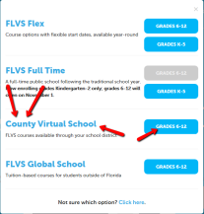

- New Student or Already Have an Account? If you are a new student create your account.
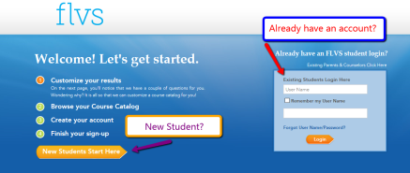

- Once signed up, you will be taken to your “Student Dashboard”. Click the menu symbol, then click Request New Course
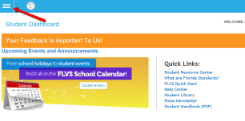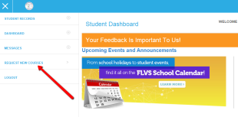

- In the search section go to Subject, then click on Safety and Driver’s Education.
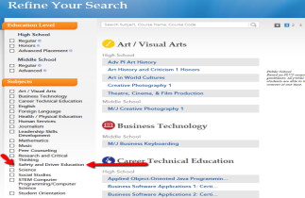

- Choose Segment 1. Choose your preferred start date. Choose POLK COUNTY VIRTUAL SCHOOL. 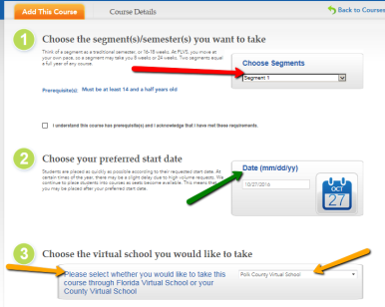

- Once placed into the course you will get an email sent to the email address you gave when you created your account.

- You can then go to flvs.net; Log In using your Username and Password. You will see Safety and Driver’s Education under your course list! CLICK it and BEGIN!
