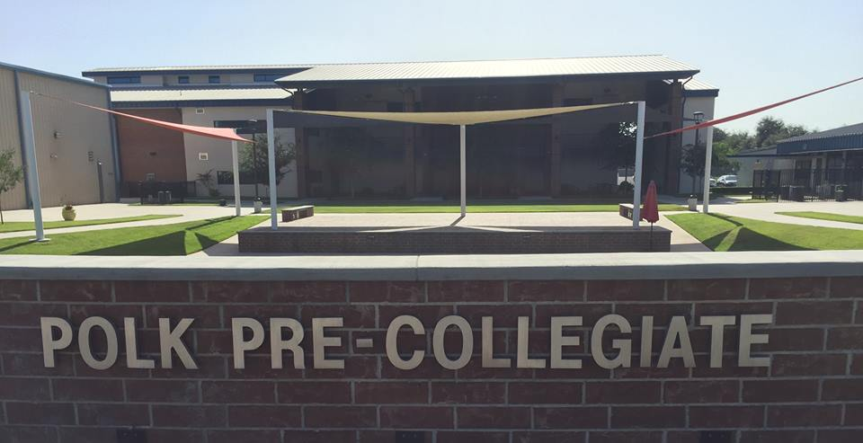

**PPCA Board of Directors**

**Meeting Calendar**

**2021-2022**

**Location: PPCA Room 4203**

**Time: 6:00 p.m.**

**Board Meeting Calendar**

August 23, 2021

October 11, 2021

December 13, 2021

February 7, 2022

April 11, 2022

June 20, 2022

Audit Committee Meeting: October 11, 2021 at 5:30 p.m.

Annual Board Meeting: June 20, 2022 at 5:30 p.m.

**Polk Pre-Collegiate Academy**

Discover - Decide - Defend